MANAGEMENT INFORMATION SYSTEM

LAB EXPERIMENTS

Jashwini A-192124192

10) Draw a use case diagram for Library Management System is an automation system used  to manage a library and the different resource management required in it like  cataloguing of books, allowing check out and return of books, invoicing, user  management, etc. The user can search for books details using few book properties  (Book ID, Title, Author, and Publisher). Searching should return details about all the  book copies that match the search query.

**Aim:**

To develop a **Use Case Diagram** for a **Library Management System**, which automates library operations such as cataloging, book searches, checkouts, returns, invoicing, and user management.

**Procedure:**

1. **Identify Key Actors:**
   * **Library User (Member)**: Searches for books, checks out, and returns books.
   * **Librarian**: Manages books, processes checkouts/returns, and handles invoices.
   * **Library Management System**: Stores book details, manages user accounts, and tracks book transactions.
2. **Define Major Use Cases:**
   * **User Use Cases:**
     + Search Books (by Book ID, Title, Author, Publisher)
     + View Book Details
     + Checkout Book
     + Return Book
   * **Librarian Use Cases:**
     + Manage Book Catalog (Add, Remove, Update Books)
     + Process Checkout
     + Process Return
     + Generate Invoice
     + Manage Users (Add, Remove, Update Library Members)
   * **Library Management System Use Cases:**
     + Maintain Book Database
     + Track Issued Books
     + Generate Overdue Notices
3. **Establish Relationships:**
   * **Library User** interacts with the **Library Management System** to search for books, check them out, and return them.
   * **Librarian** manages books, tracks due dates, and handles invoices.
   * The **Library Management System** ensures records are updated with each transaction.

**Output:**

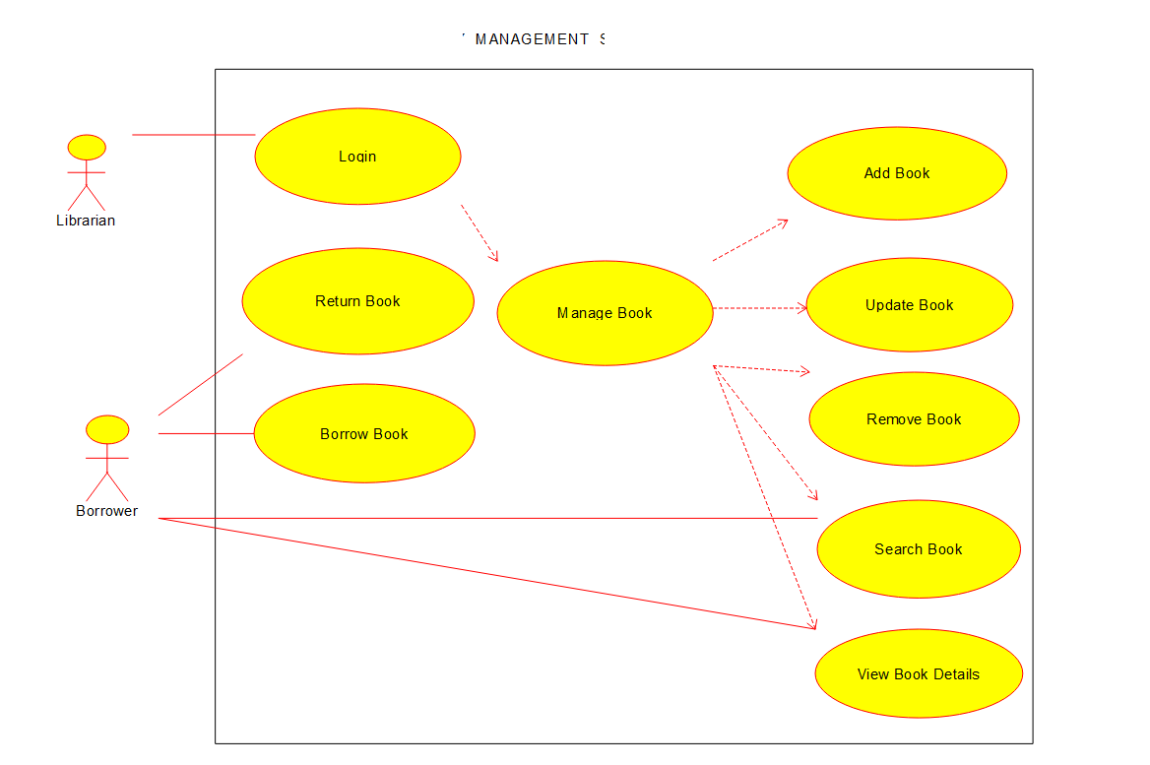

**Use case diagram**

**Result:**

A **UML Use Case Diagram** will be created based on the above analysis.